Simple Rocket Motor Grain Burnback Regression with Fast Marching vs. Level Set

Joseph Grinberg
School of Computing, Binghamton University
CS301: Ethical, Social, and Global Issues in Computing
Dr. George Weinschenk
February 14, 2026

Simple Rocket Motor Grain Burnback Regression with Fast Marching vs. Level Set
Humans last walked on the moon in December 1972. Six decades later, NASA expects humans to walk on Mars. Increased aspiration to settle the world beyond current reach has heightened the importance of reliable and powerful propulsion systems. Solid rocket motors (SRM) are an approach where propellant in a solid state provides easy storage and use. Difficulties often arise when determining the behavior of a specific propellant shape (grain geometry) during regression, making precise modelling methods key to success. Compared with the Fast Marching Method (FMM), the Level Set Method (LSM) is a more accurate and adaptable voxel (3-Dimensional pixel) based algorithm for modelling 3D grain surface regression, yielding improved performance and increased safety for solid propulsion systems. FMM follows a static framework like Dijkstra's by computing a single-pass arrival time, making it faster but less precise for complex grain geometries. LSM models regression by computing distance continuously through time. To understand why LSM performs optimally, the foundations and limitations of FMM require examination.

Fast Marching Method Technical Background
FMM is rooted in the mathematics of wave propagation and shortest path computation. It was designed to solve problems with moving boundaries, such as snow melting, seismic wave travel, computer vision for robotics, or medical imaging. The speed function F of a regression remains positive at all times, meaning that at any point in time, the boundary of an object or wave will continue moving outwards at a fixed speed. In ideal cases, SRM propellant burning follows these exact characteristics. As a result, FMM treats grain burnback as a propagating surface moving through a grid, computing arrival times at each point.
FMM begins by discretizing the grain geometry into a 3D grid with voxel height h. Each point gets assigned to a group in a matrix that holds every point in the grid. The matrix holds the value 1 for a point that has been found, 0 for a point whose time is currently in trial and being estimated, and -1 for a point whose time is far. Another matrix with the same size as the grid simultaneously stores the time of every point. At the beginning of the simulation, the surface points get assigned time 0, and every neighboring point gets marked as a trial. For each trial point, a quadratic formula (1) gets computed. The equation takes the shortest known neighbors’ time on all three axes to approximate a discretized version of the Eikonal equation (2). After a few passes, Figure 1 represents how the wave of trial points would look moving through a grid.
(T - T_{xmin})² + (T - T_{ymin})² + (T - T_{zmin})² = h²/F² (1)
|ΔT| = 1/F (2)
Figure 1
The Known, Neighbor, and Far Points on a 2D Grid
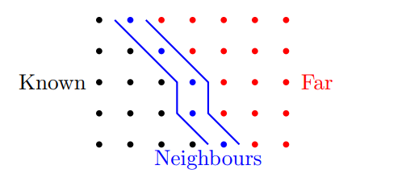
After the trial point estimation, the times are stored on a min-heap. A min-heap is a tree data structure with the smallest element stored at the root and each parent larger than its children. At every step, the smallest node gets inserted into the time matrix. The same nodes’ far neighbors then go into trial, computing the same equations and getting inserted into the tree as shown in the flow chart, Figure 2. Insertion starts at the bottom and bubbles up, checking for larger parents, and moving up if so. The algorithm completes once all points get inserted into the time matrix, allowing burn surface reconstruction at any time stamp.
Figure 2
Flow Chart of FMM
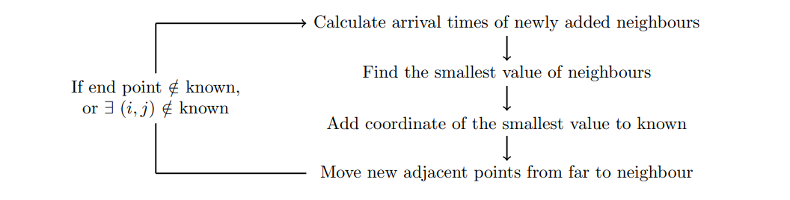
FMM was validated by Bhattacharya and Mundhra, two mechanical engineers who studied in India. Their paper, written in 2025 on the effect of different grain fractals for SRMs, discusses the effectiveness of FMM when taking 2D splices to model regression. The upside with FMM arises when considering uniform geometry, since the surface will regress at the same rate of speed everywhere. By taking 2D splices, the shape of a uniform 3D object does not get ruined, allowing for more complex fractal grain modelling. The more complex a fractal grain becomes, the more efficiently it burns (Bhattacharya & Mundhra 2025, p. 9). As Table 1 shows, there are notable impulse and burn time errors with a star grain (Bhattacharya & Mundhra 2025, p. 4). The error results from two key factors within non-idealized SRM regression: Topology change and erosive burning. FMM handles two waves reaching the same point by taking the one that reached it quicker. In reality, both waves are acting on that point. With more complex geometries, the error compounds from every mistake. Secondly, erosive burning causes changes in the speed of burning, which FMM can not take into account. Instead, LSM computes the continuously evolving boundary through time, eliminating these limitations.
Table 1
Comparison Between Actual Motor Test and Simulated Motor Test using OpenMotor
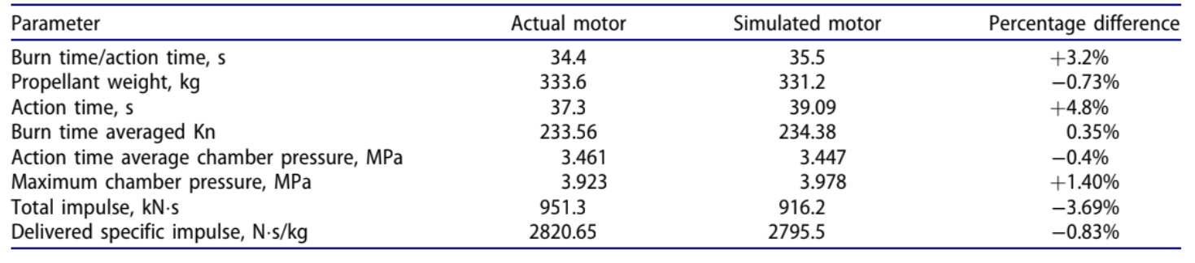

Level Set Method Background
The level set method approaches grain burnback regression as a continuously evolving boundary problem by assigning every voxel in the 3D grid a distance from the surface. Voxels inside the unburned grain are assigned a positive distance. A negative distance gets assigned to a voxel that has already burned. The surface voxels that are currently being burned are given the value 0. Every distance value is stored at the center of the voxel. These distance assignments across the entire grid form the signed distance field (SDF) phi (φ) as seen in Figure 3. LSM implicitly models the surface moving by extracting where φ is zero, called the zero level set, on the current grid rather than storing the surface at every time. Maintaining a coherent grid across the entire simulation resolves complex topology changes. Additionally, LSM can handle erosive burning because F gets recalculated at every step.
Figure 3
Signed Distance Field
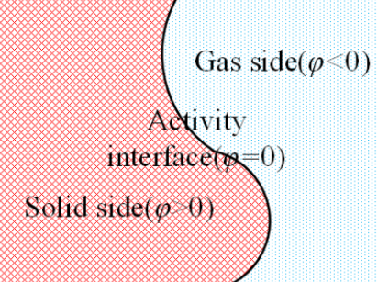

Level Set Method Technical Detail
Before beginning, the 3D voxel grid gets created alongside two matrices of the same size. Each voxel gets assigned a coordinate (i,j,k) holding a φ value in one matrix and an F value in the other matrix. Each 3D matrix gets stored as a single-dimensional array with specific indexing math to find each coordinate value. In order to generate the initial SDF, each voxel needs a minimum distance field (MDF) and a sign value.
Wei et al. (2018), engineers at Northwestern Polytechnical University in the Science and Technology on Combustion Internal Flow and Thermal-Structure division, implement an efficient scanning-based method for SDF initialization called DiFi. Brute forcing calculations for each voxel would require hours of operation, whereas a method for using smaller local subsets of voxels proves more efficient (Wei et al, 2018, p. 3). Difi sweeps the grain in one direction with a line, splitting elements into three groups. Figure 4 shows the already swept, active, and approaching groups in green, red, and blue, respectively. To calculate a voxel’s minimum distance, only those voxels close to it need to contribute, so by only using the red group, computational time dramatically decreases (Wei et al, 2018, p. 3). Lastly, the propagation runs again in the opposite direction to double-check for the shortest distance. A ray cast from each voxel finds if any boundaries are intersected, determining where the voxel resides. After initializing the SDF matrix, the speed matrix must be filled.
Figure 4
DiFi Demonstration
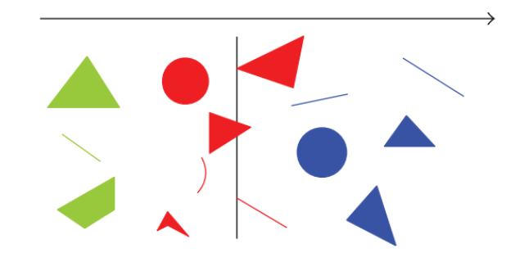
Vielle’s burn rate law (3) helps calculate F for each voxel using specific burn rate constants a and n defined by the propellant chemistry. P defines the value of local chamber pressure.
F = aP^{n} (3)
At the beginning, the F matrix gets assigned base values because P is approximately uniform. The F matrix only becomes spatially variable once the simulation starts running and the flow of gas produces different velocities. Liu et al. (2023), engineers at the School of Aircraft Engineering and Nanchang Hangkong University, study surface regression under erosive burning. In order to properly model the regression of a complex SRM, non-uniform gas distribution has to be accounted for (Liu et al, 2023, p. 1). The Lenoir and Robilland model computes the corrected F to account for erosive burning using equation 4.
r = ap^{n} + $α$(G^{0.8} / D^{0.2}) e^{(−βr₀ρc/G)} (4)
G and D are the main drivers of erosive burn rate as they change at every time step. They define the amount of gas moving across a particular point (gas mass flux) and the diameter of the port (area through which the gas is moving). The rest of the variables are coefficients derived from thermal properties and don’t change throughout the simulation (Lui et al., 2023, p. 4). The corrected F gets re-inserted into the matrix after every time step when the simulation begins.
After the simulation begins, every voxel gets changes based on how the surface is moving (Lui et al., 2023, p. 5). The continuous Hamilton-Jacobi level set equation (5) governs the evolution of the burn surface.
ꝺφ/ꝺt + F|Δφ| = 0 (5)
The partial derivative of φ describes how φ changes at the given time on a specific voxel. The gradient magnitude |Δφ| encodes the direction of surface movement. Lui et al. discuss a common method for approximating |Δφ| in the discretized case using Gogunov’s scheme on pages 5-6. Gogunov’s scheme computes the forward and backward finite differences of each axis using equations 6 and 7.
D⁻ˣᵢⱼₖ = (φᵢ − φᵢ₋₁) / h (6)
D⁺ˣᵢⱼₖ = (φᵢ₊₁ − φᵢ) / h (7)
Each comparison produces a slope that measures how steeply φ changes between neighboring voxels, which get assembled into a positive and negative (although not needed for SRM burnback) central difference Δ using equations 8 and 9.
∇⁺ = (max(D⁻ˣ,0)² + min(D⁺ˣ,0)² +
max(D⁻ʸ,0)² + min(D⁺ʸ,0)² + (8)
max(D⁻ᶻ,0)² + min(D⁺ᶻ,0)²)^{1/2}
∇⁻ = (max(D⁺ˣ,0)² + min(D⁻ˣ,0)² +
max(D⁺ʸ,0)² + min(D⁻ʸ,0)² + (9)
max(D⁺ᶻ,0)² + min(D⁻ᶻ,0)²)^{1/2}
The final update at a voxel (i,j,k) takes the discretized version of the Hamilton-Jacobi equation (10), where φⁿᵢⱼₖ represents the current value and φⁿ⁺¹ᵢⱼₖ represents the new value.
φⁿ⁺¹ᵢⱼₖ = φⁿᵢⱼₖ − ΔtF∇⁺ (10)
However, thousands of iterations cause a slight oscillating error, where an overshoot in the correct φ value occurs and then gets overcorrected on the following calculation. To combat the error, Lui et al. use a TVD Runge-Kutta scheme (11) that runs equation 10 three times with intermediate φ values and combines them into a weighted average.
φⁿ⁺¹ = (1/3)φ^{(n+1/2)} + (2/3)φ⁽³⁾ (11)
The stable φ^{n+1} then overrides the final F value in the matrix. Equation 11 only stabilizes the advancement of φ close to the zero level set because the sharpest changes happen there, leaving further φ values to accumulate estimation errors and slightly drift.
Reinitialization essentially re-runs the SDF computation on the entire grid to confirm every voxel has an accurate distance from the zero level set, removing the drift of far voxels. Lui et al. handle reinitialization on pages 7-8 by checking whether a φ value is different from the true distance as computed by the MDF, and updating the value accordingly. Since the surface never gets explicitly stored, extracting the burn surface into a visual model requires additional steps.
In practice, a singular φ never takes on the value 0. On a discrete grid, the surface would lie somewhere between a positive and a negative value, not exactly inside a voxel. A common method called marching cubes, which Wei et al. incorporate, finds an interpolation between a positive and a negative voxel. When two neighboring voxels are different in sign, the surface must lie between them. The surface points are then connected into a triangular mesh. As the simulation propagates, the mesh does so too, accurately displaying what the burn surface looks like with erosive burning and topological changes.

Analysis
The challenge in modelling an SRM erosive burn regression comes down to the physical properties of how rockets burn. Depending on where the flame comes out and the grain geometry, an SRM can burn completely differently. Figure 5 exemplifies how chamber pressure affects burn rate and thus makes one side burn like a staircase into the other side. Figure 6 shows how a simple grain will not burn uniformly because erosive burning changes mass flux. The biggest issue with FMM was the inability to change F after starting. In practice, all SRMs experience erosive burning, which leads to topological changes even with simple grains. LSM overcomes this by continuously updating F. Burning surface area curves for star geometries produce measurably different results, as shown in Figure 7. This result was confirmed by Bhattacharya and Mundhra in Table 1. As LSM does more computation, it ultimately takes a lot longer than FMM. However, many researchers have found ways to optimize LSM.
The strength in LSM comes from how adaptable it can be with other methods. Since FMM computes once and never updates values, coupling it with a flow solver produces no benefit since the boundary condition never changes (the speed of regression). LSMs’ continuously evolving field provides a boundary condition for coupled simulations. Zhang et al. (2021), engineers at the Air Force Engineering University in Xi’an, explore a coupled simulation with the Volume of Fluids Method (VOF). The engineers successfully overcame the shortcomings of calculating full transient internal flow (pressure, temperature, and velocity) because LSM provides a live boundary condition during every time step (Zhang et al., 2021, p. 10). Wei et al. further explore optimization using GPU parallelism and Boolean operations to reduce run time by 15 and keep error under .25% (Wei et al., 2018, p. 10). The benefits of modelling SRMs have implications that extend far beyond simulation accuracy.
Figure 5
Regression With Differing Burning Rates
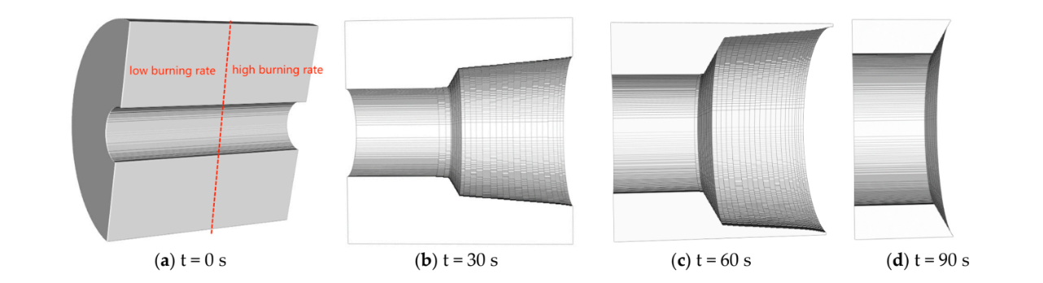Figure 6
Erosive Burning on Uniform Geometry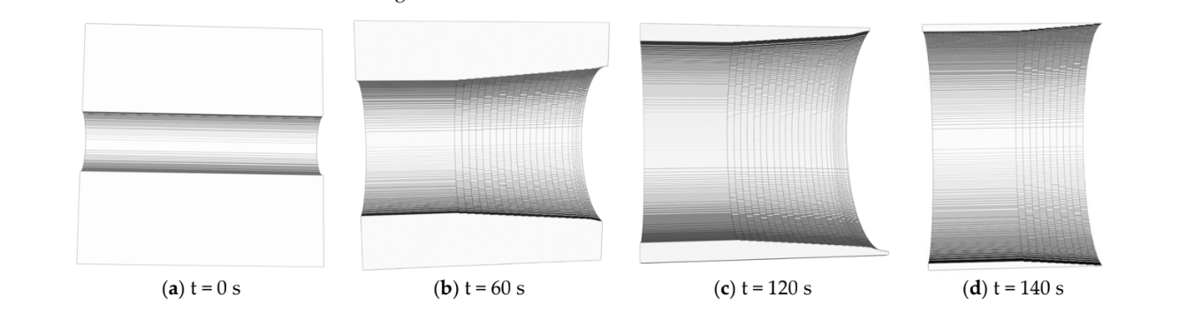

Figure 7
Comparison Between Star Grain Burning Surface Area With and Without Erosivity
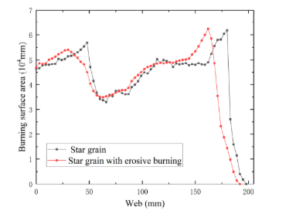

Social Impact
The differences between how FMM and LSM handle grain burnback regression carry consequences well beyond accuracy. During the design of an SRM, engineers use simulations to dictate how a specific motor may behave. Once the numbers meet expectations, that motor gets replicated during manufacturing. If a simulation underestimates burn time or misrepresents the thrust profile, the rocket could underperform during a critical mission. Since FMM makes the speed constant, it does not serve as a supplement to real-world physics. In an industry where failures can destroy payloads worth hundreds of millions of dollars or endanger life, the choice of simulation becomes an ethical decision with direct implications on the real world.
Nancy Leveson, a professor of Aeronautics and Astronautics at the Massachusetts Institute of Technology, addresses the relationship between simulations in technology and safety in her Communications of the ACM article “Are You Sure Your Software Will Not Kill Anyone?” (2020). Leveson argues that reliability and safety represent two entirely different principles, and even when a system is reliable, it can still produce harm (2020, p. 2). Even though a program itself is not capable of producing harm, it possesses implied harm if used without properly understanding what it should be used for. Leveson demonstrates the distinction with an example of firing a gun in an open field versus in a crowd of people (2020, p. 2). The mechanism stays the same and produces the same shot every time, but the safety conditions are vastly different. Although FMM produces consistent results in a field where 3% error may not make a difference, like a smaller SRM as a home project, using it for industry-level missiles or rockets with lives at stake proves unsafe. Leveson further argues that accidents caused by software stem from incorrect models that can give false results or behave differently than expected (Leveson, 2020, p. 1-2). Simulations built on FMM give false results since they do not accurately display topological changes or erosive burning. Adopting LSM corrects the underlying model, addressing the root cause of inaccuracy in FMM.
Beyond correcting the model itself, LSM was built for next-generation simulation tools. Karen Willcox, an aerospace engineer and Director of the Oden Institute for Computational Engineering and Sciences at The University of Texas at Austin, explains digital twins in her 2023 TED talk “How Digital Twins Could Help Us Predict the Future.” A digital twin acts as a personalized, evolving model of a physical system (Willcox, 2020, 4:07). The strength of a digital twin comes from being able to test anything before applying it to a physical object. A simulation, on the other hand, serves as a broad estimate for any system. A digital twin assimilates data from the current state of an object to model it 1-1, but in a digital state (Willcox, 2023, 1:33). As the aerospace industry moves towards digital twin modelling for launch vehicles, data must be accepted at every time step to adjust predictions accordingly. LSM satisfies just that, with the ability to couple with other flow solvers and physics models. As grid resolutions increase and computers become faster, the gap between LSM simulation and physical motor behavior shrinks. That shrinking gap moves the aerospace industry closer to safer and more reliable production of propulsion systems.

References
Alblas, D. (2018, June 30). University of Twente bachelor thesis implementing and analysing the fast. https://essay.utwente.nl/fileshare/file/75601/Alblas_BA_EWI.pdf
Bhattacharya, S., & Mundhra, R. (2025). Effect of using fractals as grain configuration on the performance of solid rocket motors. Heat Transfer Engineering, 46(9–10), 852–864. https://doi.org/10.1080/01457632.2024.2347178
Leveson, N. G. (2020). Are you sure your software will not kill anyone? Communications of the ACM, 63(2), 25–28. https://doi.org/10.1145/3376127
Liu, S., Lu, H., Zhang, B., Yang, Y., & Sang, D. (2023). Study on burning surface regression algorithm under erosive burning based on CT images of solid rocket motor grain. Aerospace (MDPI Publishing), 10(1), 21. https://doi.org/10.3390/aerospace10010021
Wei, R., Bao, F., Liu, Y., & Hui, W. (2018). Combined acceleration methods for solid rocket motor grain burnback simulation based on the level set method. International Journal of Aerospace Engineering, 2018, 1–12. https://doi.org/10.1155/2018/4827810
Willcox, K. (2023, September). How digital twins could help us predict the future [Video]. TED Conferences. https://www.ted.com/talks/karen_willcox_how_digital_twins_could_help_us_predict_the_future
Zhang, Z., Gao, F., Lv, R., & Gao, Y. (2021). Coupling of level set and volume of fluid methods for simulations of transient internal flow field in solid rocket motors. International Journal of Aerospace Engineering, 2021, 1–11. https://doi.org/10.1155/2021/2984992

